SPRING ISSUE
it's time to put a spring in your step with the latest issue of SYC Family Project  News! | It has been an amazing start to the year, not just for young carers in Sheffield but from all over the UK > > > | We've received some whopping big grants from the Big Lottery Fund to fund our family Project for the next 4 Years!!! – Funding for new family support Workers and our New project MPACT!
SYC Family NEWS
A 'blooming' Amazing start this year we have Funds! | Talks that we will be supporting families with drug and alcohol issues!

We will make a “MPACT” on families who are struggling with addiction this year!

You probably have noticed your family team have been very busy! You may have experienced delays in your responses. The family team would like to say thank you for your patience, we have been training with “MPACT”. We will soon be launching a new service, where we will be supporting families who are struggling with addiction. We will be having new staff onboard to support this. So hold on its going to be a blast.
“M-PACT is a whole family, multi-family, structured brief intervention. Its psychosocial, educational and systematic approach, aiming to improve the well-being of children and families affected by parental substance misuse. The programme supports families to address areas such as communication and coping strategies as well as educating family members on what addiction is and the impact it has. It is now one of the longest standing interventions for parental substance misuse in the UK and continues to be a unique and innovative programme, which puts children at its heart.”
https://www.forwardtrust.org.uk/service/m-pact-programme/

Page 1 – April Issue
Hayfever Alert, the flowers are growing!
School holidays! Book A Break!
We all deserve a break, with Covid and restrictions reduced the holiday season is going to be blooming busy. I would book your holidays ASAP and remember the schools do like to charge if you take the kids during term time. Your children’s education is important but so is a break! So we will let you decide. Some of you may have heard of the Family Holiday Charity- yes they provide free holidays to families on low incomes. We have supported many families with this.
Reach for the Sun! £9.50 Holidays are back
Sun Holidays provide cheap caravan holidays, just collect the codes and apply on the 2nd April - £9.50 Per person “A Bargain”. PS – You don’t need to buy all the papers there online SHHHHH. https://www.mybudgetbreak.com/holidays/sun-holiday-codes-including-9-50-holidays

School Holiday Dates -
It’s that time again when we start to feel sniffly, and itchy, yes, it’s time to get the Anti - histamines out, please check the use by date don’t use last years. Also, the cheap brands are just as good! Not all bad though as we are growing to. We should have some more lovely team members joining us to give you the support you require. We are shortlisting this month!
- 3rd to 14th April 2023
- 1st May 2023
- 8th May 2023
- 29th May to 2nd June 2023
- 1st to 2nd June 2023
- 24th July to 31 August 2023
New Seeds have arrived!
We have planted and a new seed in the team, please welcome Rachel our new family Support Worker. She is enthusiastic and ready grow. Please be patient plants need time to settle in their environment, and other plants roles will be adapting. But the Flowers will come!
We are plotting Something !
Summer is not far, so we a plotting a lovely sunny family day out, to take place in the next holidays. We will let you know soon, just keep smiling.

Spring’s TIGHT !
Have you seen a new children’s park! SYCP have been spying – There’s a new park opening on 3rd April it’s called Pounds Park. The playground includes two large pyramid towers, stainless steel slides, climbing structures, playhouses, a seesaw, wheelchair-accessible play equipment and more.
Pound's Park is located on the corner of Rockingham Street and Wellington Street.

We can’t deny money is tight but breath we can go outside it’s getting brighter – Need support – Sheffield Council have a helpline - find out about support funds, council tax discounts, benefits and more.
helpline: 0114 273 4567

I spy a new park !

Volunteering Opportunities
Community Park Ranger Volunteer
Organisation - Heeley Trust
Website - http://www.htcommunityhub.org This link will open a new window.
Job - Fancy helping us to maintain and develop a really special community owned park in Sheffield? Then this opportunity could be for you!
You'll be joining us at Heeley People's Park, we are community owned and need your help to maintain the Park (much TLC is needed after a summer of growth). It's an amazing opportunity to spend some time in nature, develop some horticultural skills and enjoy some good company.

Sheffield Council – Reading Volunteers Needed!
Make a difference in your community by helping children in Sheffield improve their reading and communication. Volunteer to help children with one hour of reading a week.
You can read our volunteering welcome pack if you are interested in volunteering. It will give you some general information about the role and what you can expect.
You can apply by downloading the reading volunteer application form and sending it by email to escalvolunteering@sheffield.gov.uk.

Volunteer’s are wanted!
Thousands of people volunteer in Sheffield for a huge range of charities, community groups and organisations. Volunteering can be great fun and you can make a real difference not only to others, but also to yourself. To find out how other people have benefitted from volunteering, see our Stories page.
There are hundreds of volunteer opportunities to explore and the Volunteer Centre is here to help you find a role to get involved in.
See the Start Volunteering page with information about our:
- Drop-in service (open Tuesdays 10am - 4pm)
- Email/phone advice
- Online database of roles where you can explore all the current opportunities and apply for them online:
or
- Bulletins which list the latest opportunities
Have a look at Louise Martin's story - could volunteering transform your CV?
“Don't think "I won't be able to do that". Just give it a try. Organisations are often willing to train you and you'll probably surprise yourself.”
What’s On Guide

Longshaw Estate

When? 1st – 16th April
Address: Sheffield S11 7TZ
Event – Easter Egg Hunts A Bit About – Make your way along the trail and find nature-inspired activities for the whole family. Come along and explore the beautiful woods and moorland of Longshaw.

National Emergency Services Museum
When? 7th – 10th April
Address: Old Police/Fire Station, W Bar, Sheffield S3 8PT
Event – To the rescue A Bit About – Join us for a jam-packed Easter weekend of fun for all the family as we celebrate our everyday superheroes of the emergency services!
More events to be found at www.welcometosheffield.co.uk

In Crisis , what do I do?
Sheffield Parent Hub
Sheffield City Council,
https://www.sheffield.gov.uk/home/social-care/positive-parenting
Email: sheffieldparenting@sheffield.gov.uk
- Provides parenting courses, advice and support!!
Mental Health Crisis
If you or a loved one is already receiving support from social care services, and you are in a mental health crisis and need urgent help, please contact your Care Co-Ordinator straight away.
If your service is closed for the day or you do not currently receive support from social services and you need urgent help you can contact the Single Point of Access on 0808 196 8281 (calls are free from a landline or mobile) or 0114 226 3636. They are available 24 hours a day, seven days a week.
If you or a loved one are aged under 18 you need to contact the Child and Adolescent Mental Health Service (CAMHS) at Sheffield
Sheffield Food Bank
http://www.sheffieldfoodbank.org.uk/help-me/
This website will help you find a food bank that covers your local area. In many cases, you will need a third-party who is already supporting you (such as a GP, Social Worker, or tenancy support worker) to plan on your behalf to access a food bank.
If you don't know who to turn to for help, please think about contacting Advice Sheffield by visiting www.advicesheffield.org.uk or calling 03444 113 111.
Sheffield Rethink Helpline
Available 24 hours a day, seven days a week, the Sheffield Rethink Helpline can offer advice to anyone struggling with their mental health.

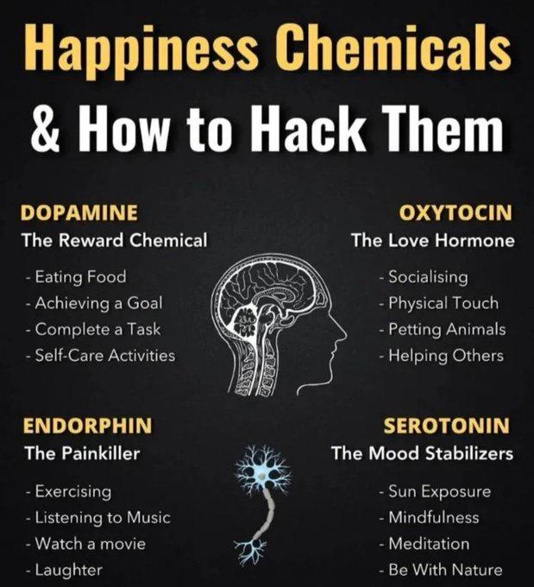
You can call them on 0808 801 0440. Calls are free from a landline or mobile.

Easter Recipe

Ingredients

225g/8oz dark chocolate, broken into pieces

2 tbsp golden syrup

50g/2oz butter

75g/2¾oz cornflakes

36 mini chocolate eggs

Method

Line a 12-hole fairy cake tin with paper cases.

Melt the chocolate, golden syrup and butter in a bowl set over a saucepan of gently simmering water (do not let the base of the bowl touch the water). Stir the mixture until smooth.

Remove the bowl from the heat and gently stir in the cornflakes until all of the cereal is coated in the chocolate.

Divide the mixture between the paper cases and press 3 chocolate eggs into the centre of each nest. Chill in the fridge for 1 hour, or until completely set.

Recipe Tips

Shredded wheat or puffed rice cereals can be used instead of the cornflakes.

Need to Chat!
Don’t forget we have our parent only! What’s APP Groups – Message Danielle our Family Engagement Worker to join! Warning There’s lots of events and advice which could change your life! – Contact Danielle – Danielle.ball@sycp.org.uk

www.sheffieldyoungcarers.org.uk
Registered charity number 1140105 Company Limited by Guarantee 7461229

