**Please always download this form from our website to ensure you are using the most up to date version** [**www.sheffieldyoungcarers.org.uk/make-a-referral**](http://www.sheffieldyoungcarers.org.uk/make-a-referral)

**Referral Information**

##### What we offer?

##### SYC offers one year of support to:

##### Children and young people aged 8-25 who live in Sheffield and are caring for someone in their family who has a physical or mental illness and/or a disability.

##### Children and young people aged 8-25 who live in Sheffield and are affected by drug and alcohol issues in their family (now or in the past).

##### We also have family support workers who may be able to support your family, where appropriate.

##### Our support includes one-to-one support, group support and school / college holiday activities. For details, see: [www.sheffieldyoungcarers.org.uk/help-for-young-people](http://www.sheffieldyoungcarers.org.uk/help-for-young-people)

**Who can complete this form?**

This form can be completed by either:

* Young carers / young people affected by substance misuse issues in their family
* Family members (with consent and involvement of the young person)
* Professionals (with consent and involvement of the young person)

**Is this the right project? Our service criteria:**

* You MUST have the child’s/young person’s consent and preferably also parent/guardian consent (please talk to us if the young person doesn’t want parental involvement).
* The young person must be either:
  + a young carer, e.g. they are helping to care for a person who is ill, has a disability, is experiencing mental ill health, or is misusing alcohol/drugs
  + a child / young person affected by drug and alcohol issues in their family
* Caring responsibilities and / or substance misuse in the family are in some way impacting on their lives. This may be socially, educationally, physically or emotionally.
* The young person must be between 8 and 25 years and live in Sheffield.
* We can only support **one sibling** from a family at a time (the child most impacted).

**How do I apply for SYC? Our referral process:**

When completing our form, please put as much information as possible on the form. However, if you don’t have all the information, please fill in as much as you can and we will follow it up at a later stage.

Our referral process is also detailed on the next page. Please print this and give it to the young person, so they know what to expect while they are waiting for our service.

If you have any further queries or want to discuss the child / young person before you complete the referral form, including if you are unsure if the young person meets the criteria, please do not hesitate to contact us on telephone 0114 258 4595.

**Please return a signed copy of this form by post to:** Sheffield Young Carers, Unit R7b Riverside Block, Sheaf Bank Business Park, 20 Prospect Road, Sheffield, S2 3EN

**We recommend you keep a photocopy of this form, in case it gets lost in the post.**

**Professionals: Please also give a copy of the completed form to the young person/family so they can refer back to it.**

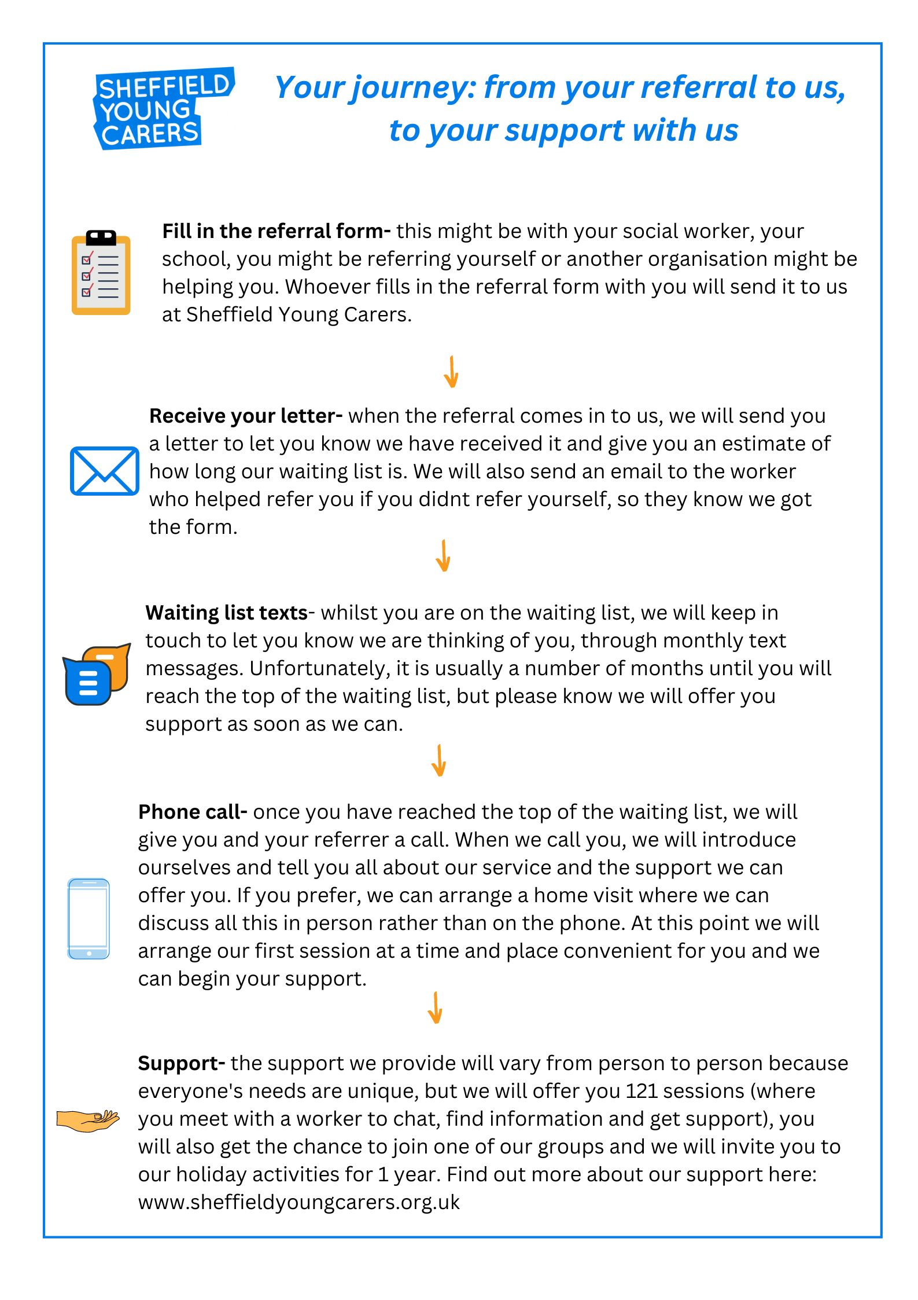

FOR OFFICE USE ONLY: Date referral received: __________

**SHEFFIELD EARLY HELP ASSESSMENT FORM**

**Information Sharing and Consent:** As the person helping you to complete this form has explained, we want to be able to provide services

to you and your family. To do this efficiently, we will need to share some of the personal information you have supplied with services

already working with you or that you may benefit from.  Please agree to this by signing below.

I agree to the sharing of information between the relevant agencies and all family members including young people as appropriate. I understand that the information gathered regarding my family is recorded and will be securely stored and used for the purpose of providing services to my family and may also be used for monitoring and auditing.

**Name: Signature: Date:**

Is there anyone you do NOT want us to share information with?

*If this form is being used to carry out a statutory duty and no consent is needed, please state the relevant statutory duty……………………………………………*

**Is the child/young person aware of this assessment taking place?** Yes / No

**Family Details** *(Please include all family member details and as much information as possible to enable quick access to support)*

| **Surname, Forename/s** | **Address including postcode** | | **DoB** | **Gender** | **Ethnicity** | **Relationship to Child/ young person 1** | **Current Educational setting** | **Attendance%** | **Exclusions** |
| --- | --- | --- | --- | --- | --- | --- | --- | --- | --- |
|  |  | |  |  |  | N/A Child/YP 1 |  |  |  |
|  |  | |  |  |  |  |  |  |  |
|  |  | |  |  |  |  |  |  |  |
|  |  | |  |  |  |  |  |  |  |
|  |  | |  |  |  |  |  |  |  |
| **The purpose of this form is:** | |  | | | | | | | |

|  |  |
| --- | --- |
| **People with parental responsibility** |  |
| **Contact details** (include phone numbers) |  |
| **Significant others living with or caring for the child/young person and trusted adults** |  |
| **Risks:** *anything that may be a risk to the family or professionals including dogs, substance misuse, any history of aggression or violence, weapons.* |  |
| **Communication needs/preferences:** |  |

|  |  |  |  |
| --- | --- | --- | --- |
| **SHEFFIELD EARLY HELP ASSESSMENT FORM**  ***Please complete all sections with coloured headings. Complete the grey sections if there are school-aged children/young people***  **Details of all known agencies/professionals involved, the impact of their involvement and any referrals made for additional support:** | | | |
| **Named professional** | **Role & Organisation** | **Work undertaken & impact so far** | **Email & Phone Number** |
| **Name of assessor:** |  |  |  |
|  |  |  |  |
|  |  |  |  |
|  |  |  |  |
|  |  |  |  |
|  |  |  |  |
| **If for Alternative Provision, 0-5 SEND, Managed Move, Reduced timetables, Internal Inclusion Provision or Exclusion please give details of the curriculum that has been accessed and learning levels:** | | | |
| **Special Educational Needs & Disabilities (SEND) / Sheffield Support Grid Information:** *(format with grid levels & state if moderated)* | | | |
| **Important/significant life events that professionals need to be aware of:** *(e.g. bereavement, parental separation, big family changes)* | | | |
| **Are there any young carers in this family?** *(give details)* | | | |
| **Have the family received additional Early Help support before?** *If so please give some brief details.* | | | |

|  |  |  |  |  |  |  |  |  |  |
| --- | --- | --- | --- | --- | --- | --- | --- | --- | --- |
| 1 | 2 | 3 | 4 | 5 | 6 | 7 | 8 | 9 | 10 |
| ☹ | ☹ | ☹ | 😐 | 😐 | ☺ | ☺ | ☺ | ☺ | ☺ |

**Family’s view: how are things going?**

|  |  |  |  |
| --- | --- | --- | --- |
| *Please discuss and agree with the family and young person whether this form is going to be used to request additional support from other Early Help services.* | | | |
| **Child/Young Person’s Voice:** (*add lines as needed)* **Captured by** *………………………….* **When & where***……………………………….* | | | |
| **What I need help with or worry about** | **What is good in my life and I enjoy** | **My hopes and wishes for the future** | **What support do I need?** |
|  |  |  |  |
| **Parents & Professionals Voice:** | (*state any differences in opinion)* |  |  |
| **WHAT ARE WE WORRIED ABOUT?** | **WHAT’S GOING WELL?** | **PLANNED NEXT STEPS** | ***What are your best hopes from this assessment?*** |
| **Education/Training & Employment** | **Education/Training & Employment** | **Education/Training & Employment** | **Education/Training & Employment** |
|  |  |  |  |
| **Health** | **Health** | **Health** | **Health** |
|  |  |  |  |
| **Independence skills** | **Independence skills** | **Independence skills** | **Independence skills** |
|  |  |  |  |
| **Care, Family & Community Factors (including housing issues)** | **Care, Family & Community Factors** | **Care, Family & Community Factors** | **Care, Family & Community Factors** |
|  |  |  |  |

|  |  |  |  |  |  |  |  |  |
| --- | --- | --- | --- | --- | --- | --- | --- | --- |
| **REFERRAL FORM Young person’s name: ______________________________   Young person’s pronouns:** ______________________________ | | | | | | | | |
| **Referrer checklist (person sending in the form)** | | | | | | | | |
| The young person has given consent to this referral (required) | | Yes □ | | | I have provided the family with a copy of this form | | | Yes □ |
| If under 18, a parent/guardian/other appropriate adult has given consent to this referral | | Yes □ | | | The family is happy to be contacted directly by a member of SYC staff | | | Yes □ |
| If you are making a **re-referral** please tell us about the reasons, e.g. change to diagnosis, increase in level of caring responsibility, relapse etc: | | | | |  | | | |
| **Young person information** | | | | | | | | |
| If the young person is in a caring role, has a [Young Carers Assessment](https://www.sheffield.gov.uk/caresupport/carers/youngcarers/needs-assessment.html) been completed? | Yes □ No□ | | | | If no please state reason: ­­_________________________________  If yes, copy attached? Yes □ No□ | | | |
| Is your **GP** aware of the family situation? | Yes □ No □ | | | | Name and address of GP | |  | |
| I consent to SYC contacting my school/college/ uni if they can’t get hold of me or my referrer | Yes □ No □ | | | | Name and role of person to contact at school/college/uni | |  | |
| Is the young person in receipt of Free School Meals? | Yes □ No □ | | | |
| **Young person to complete:** Why do you want to join SYC?  (If you have not already explained this in the Child/Young Person Voice section above) | | | | | | | | |
|  | | | | | | | | |
| Would the young person prefer a male or female worker? (We may not be able to guarantee their first choice but we’ll do our best). | | | | | Male □ Female □ Either □ | | | |
| **Reasons for referral (Please complete one or both of these columns, depending on the situation)** | | | | | | | | |
| **Information about cared-for person** | | | **AND/OR** | | | **Information about person using substances** | | |
| Name of person(s) being cared for: | | | | Name of person(s) using substances: | | | | |
| Relationship to young person: | | | | Relationship to young person: | | | | |
| Illness / disability / condition of person(s) being cared for: | | | | What substances are they using / did they use? | | | | |
| What are the impacts and needs resulting from the illness / disability / condition?(e.g. physical or emotional impacts, parenting capacity etc.) | | | | Is it current use? Yes□ No□ Are they in treatment? Yes□ No□  If yes, please give details: | | | | |
| Does the young person live with the person being cared for/using substances? | | | | Yes □ No □ | | | | |
| **Please provide an overview of the reasons for referral** if you have not already explained this on page 5 or above  e.g. types of caring responsibilities, impacts on education, health and well-being, family/peer relationships etc. | | | | | | | | |
|  | | | | | | | | |
| **Your personal data** | | | | | | | | |
| Sheffield Young Carers (SYC) is committed to protecting your privacy. We will only use your personal data to provide you and your family with the best support possible and we will always use it in line with the latest data protection guidance. **Here is a summary of how we will collect, use and store your personal information.** (Our full privacy policy can be found at: [www.sheffieldyoungcarers.org.uk/privacy-policy](http://www.sheffieldyoungcarers.org.uk/privacy-policy).)  **Collecting and using your information:**   * If you are receiving support from us, we will need to store information about you so that we can support you. * We may use your data for reports about our work. We will never include your names or any identifying features in these reports. * We will only use your data for the following purposes, with your consent (please sign below):   + letting you know what we can offer you and any changes we are making   + keeping you up-to-date with all our other work such as campaigns and fundraising   + asking for your views through occasional surveys and questionnaires   **How we will keep your data secure:** We keep your data on an electronic database and in paper files. We have systems in place to secure these against any unauthorised or unlawful processing or any accidental loss, destruction or damage.  **Sharing your personal data:**   * No one is allowed access to our system or files unless they are SYC staff / volunteers or belong to organisations that have to audit our files. This might be our funders, our accountants or researchers who have got consent to check our files. Anyone who checks our files has to work within our confidentiality policy. * We will not, without your consent, give any of your personal data to anyone else, except where we are required to do so because someone is unsafe or the police request information as part of an investigation. We will only share basic personal details with Sheffield City Council in order for them to maintain an accurate register of all carers in the city. * We will never share or sell your personal data to a third-party organisation for marketing, fundraising or campaigning purposes.   **How long we will keep your data:** By law, we have to keep your data for a set amount of time. Once this time is up, we will destroy and permanently delete all your information. You can write to us at any time to see your information while we are storing it or to request any changes to how we store and share it. | | | | | | | | |
| **Consent** | | | | | | | | |
| 1. I have read or been told about this service and I am happy to be referred. 2. I understand the summary of Sheffield Young Carers’ privacy policy. I am happy for SYC to collect, use and store my data as outlined above. 3. I am happy for SYC to contact me by: Email □Post □Phone □ Text □ WhatsApp (if over 16) □      1. I would like to receive monthly issues of SYC News (our e-newsletter) by email □Email address:___________________________________   **Signatures:** Young person: ___________________________ Parent/guardian: __________________________ Referrer:____________________  Date: ___________________________ Date:__________________________ Date:______________________ | | | | | | | | |